Montessori Fundamentals for Everyone

School-based Facilitator’s Guide

Goals of the Training
Participants will:
- Understand the basic tenets of Montessori philosophy and pedagogy
- Learn how to apply Montessori principles in their work
- Understand how to be in community with adults and children in the Montessori school

Commitments
Participants will:
- Read and/or view all course materials
- Complete all course assignments
- Conference with their school-based facilitator as directed between each part of the training
The school-based facilitator will:
- Participate in a 30-minute orientation call with NCMPS
- Read and/or view course materials
- Schedule and protect time for three conferences with participants

Course Overview

Module | Topics | Activities
1. Montessori 101 | - History of Montessori  - Montessori pedagogy | - Written reflection  - Readings  - Conference #1
2. The Prepared Environment | - The Montessori triad  - The prepared environment  - Planes of development | - Video observation  - Reading  - Conference #2
3. The Montessori School Community | - The role of the adult in Montessori environments  - The culturally responsive Montessori environment  - Reflective practice | - Reading  - Reflective practice inventory  - Conference #3

Conferences: A Guide
We recommend that the school-based facilitator read and/or view the material provided to assistants before holding each conference. These meetings are an opportunity for you to help participants contextualize their learning within your school’s unique community, tradition, and culture. Conferences can be held one-on-one or in a group, as your school’s schedule allows.

Below are some suggested questions and topics to guide your conversations with participants after each part of the training. The “Reflection Meeting Notes” form is included below for note-taking during these meetings, as well as a table to track meeting dates. After the meeting, participants will enter their notes from the form into the learning portal to move forward to the next module.

Conference #1
Ask participants to share their responses to the reflection prompts for part I. These prompts were:

- What originally drew you to working with children/working in schools?
- What do you love about this work?
- What aspects of Montessori thought and practice are resonating with you so far?
- What aspects of Montessori thought and practice do you have questions about?

Just as we seek to connect children to the environment, here, we’re seeking to help this member of the school community find a point of connection with the philosophy. Invite them to share any questions they may have about the philosophy or practices they’ve noticed in the school.

Conference #2
In module 2, participants learned about the planes of development and the role of the adult in preparing the environment to meet children’s needs at each stage of development. Invite participants to share what they noticed during their video observations (the “What’s Going On in This Classroom?” worksheet). You can also ask:

- What do you now notice or understand about the environment in our school that you didn’t notice or understand before?
- What ideas do you have for how you can better prepare your corner of the school?

Conference #3
This final conversation is an opportunity to look inward. Review the School-wide Reflective Practice Inventory with participants, and ask which items they’d like to focus on in their professional growth. Discuss what supports they might need going forward. You might also consider discussing the following questions:

- What are our school’s norms and expectations for how we will be in community together?
- What do we know about the heritages and cultures in our school community? How are we creating an inclusive environment?
- What does our school’s commitment to justice and equity look like?

Reflection Meeting Notes
Participant Name: | Facilitator: | Date: | Time:
Please list three takeaways from the reflection meeting that you participated in:
What is one goal you would like to implement based on the knowledge you gained in this module and/or reflection meeting?
What questions do you still have? What follow-up action items were agreed upon?
Please remember to use this form to report on your meeting in the learning portal before moving on to the next module in the course.

Conference Tracker
Use this optional tool to record the dates of your conference with each participant.

Name | Conference #1 | Conference #2 | Conference #3

Course Website
https://www.public-montessori.org

Course Registration
https://www.public-montessori.org/product/montessori-fundamentals-for-everyone/ (Select “Group” or “Unlimited.” Please note that the subscription option allows you to enroll unlimited participants from your school through June 30, 2024.)

Technical Assistance
pd@public-montessori.org

Enrolling New Users

When you log in, you should find yourself on the group dashboard. If not, you can navigate there by going to “My Account” in the main menu and then “Group Dashboard:”

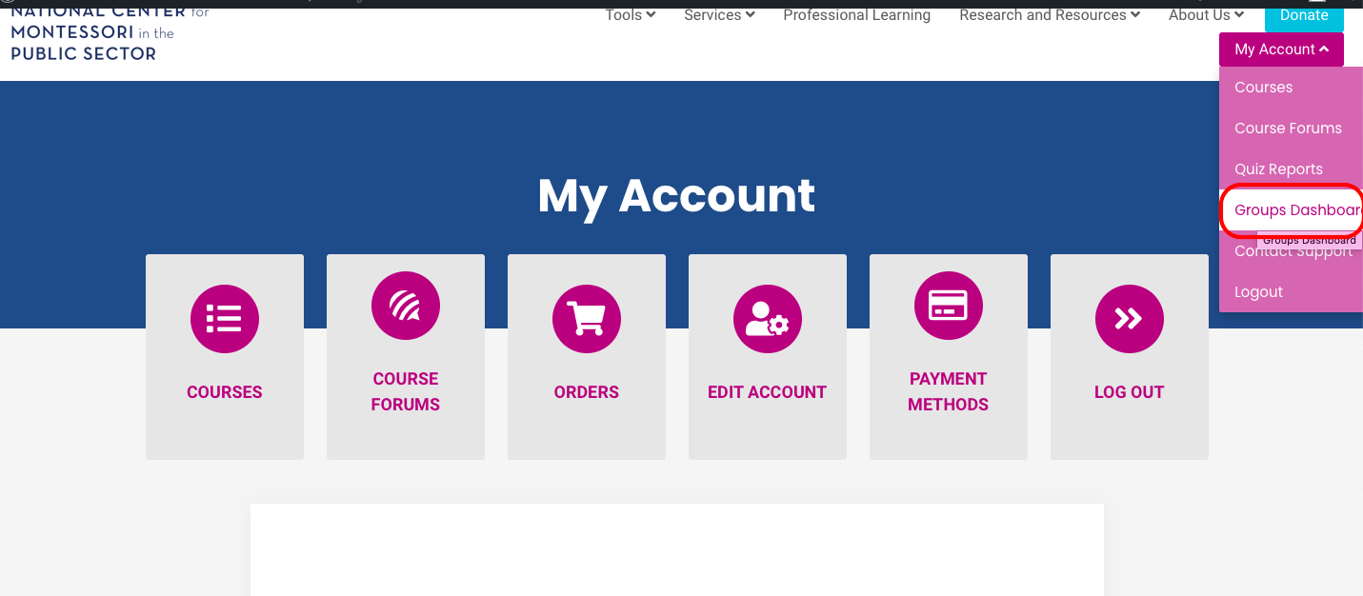

Once in the dashboard, select your group and scroll down to find the enroll new user button.

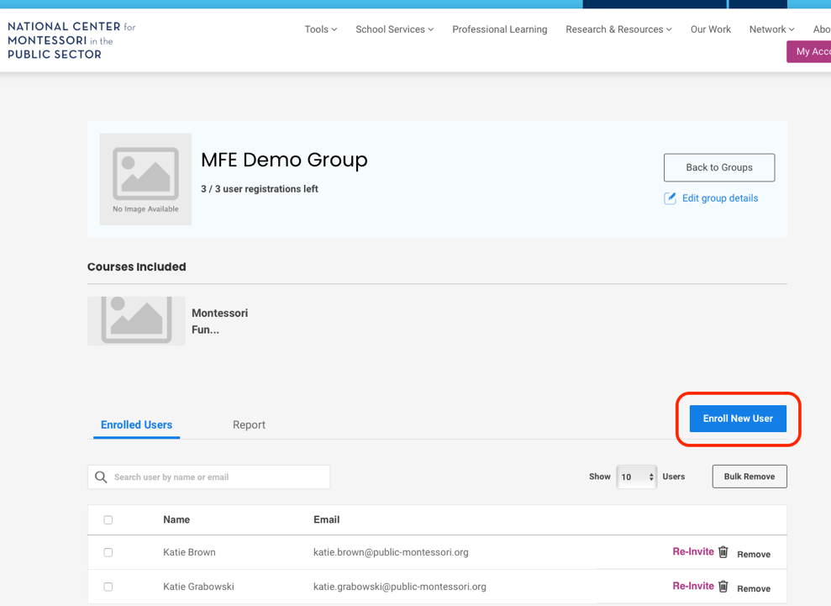

Guiding Participants to the Course

To access the course, go to https://www.public-montessori.org/ and click “Login” in the upper right hand corner. Log in to your account, then click “My Account” and select “Courses.”

Select your course from the course dashboard, then scroll all the way to the bottom and click on the course name.

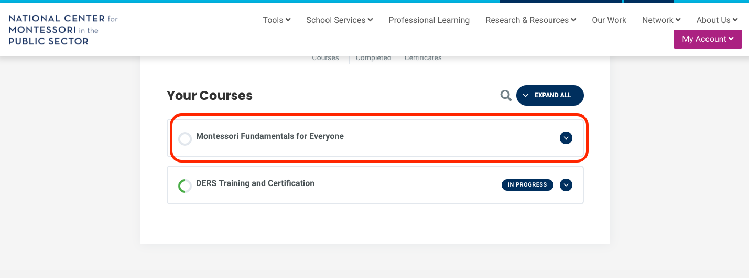

Scroll to the bottom again and you can access the course content by clicking on the module you would like to begin with.

