Assistants Training

School-based Facilitator’s Guide

Goals of the Training
The assistant will:
- Understand the basic tenets of Montessori philosophy and pedagogy
- Become oriented to the role and responsibilities of the assistant in the Montessori classroom
- Understand how to be in community with adults and children in the Montessori school

Commitments
Participating assistants will:
- Read and/or view all course materials
- Complete all course assignments
- Conference with their school-based facilitator as directed between each part of the training
The school-based facilitator will:
- Participate in a 30-minute orientation call with NCMPS
- Read and/or view course materials
- Schedule and protect time for four conferences with participating assistants

Course Overview

Module | Content | Follow-Up Activities | Deliverables
1. Welcome to Montessori | - Montessori 101  - Orientation to the Montessori environment | - Video observation  - Readings  - Conference #1 | Written reflection  Reflection meeting notes
2. Hands, Eyes, Hearts: Orientation to the Role of the Assistant | - Role and responsibilities  - Know/Do chart | - Scavenger hunt  - Reading  - Conference #2 | Reflection meeting notes
3. The Montessori School Community | - The role of the adult in Montessori environments  - Implicit bias | - Conference #3 | Written reflection  Reflection meeting notes
4. Getting Started | - Reflective practice  - Developing a personal action plan | - Conference #4 | Personal Action Plan  Reflection meeting notes

Conferences: A Guide
We recommend that the school-based facilitator read and/or view the material provided to assistants before holding each conference. These meetings are an opportunity for you to help assistants contextualize their learning within your school’s unique community, tradition, and culture. Conferences can be held one-on-one or in a group, as your school’s schedule allows.

Below are some suggested questions and topics to guide your conversations with assistants after each part of the training. The “Reflection Meeting Notes” form is included below for note-taking during these meetings, as well as a table to track meeting dates. After the meeting, the assistants will enter their notes from the form into the learning portal to move forward to the next module.

Conference #1
Ask participants to share their responses to the reflection prompts for part I. These prompts were:

- What originally drew you to working with children/working in schools?
- What do you love about working with children?
- What aspects of Montessori thought and practice are resonating with you so far?
- What aspects of Montessori thought and practice do you have questions about?

Just as we seek to connect children to the environment, here, we’re seeking to help the new Montessori assistant find a point of connection with the philosophy. Invite them to share any questions they may have about the philosophy or practices they’ve noticed in the school.

Conference #2
In part II, assistants learned about the vital functions of observing and protecting that assistants perform. Talk to your assistants about what comes up for them in thinking about this work. Review the Know/Do chart and Weekly Meeting Agenda together; talk about how assistants and guides work together in your school. Review the Scavenger Hunt document and provide answers to any items assistants weren’t able to find on their own.

Conference #3
In part III, assistants learned what it means to be part of a Montessori school community, as well as the role that implicit bias can play in how we interact with others. In this conversation, consider discussing the following questions:

- What are our school’s norms and expectations for how we will be in community together?
- What does our school’s commitment to justice and equity look like?

Conference #4
This final conversation is an opportunity to look forward. Review the Schoolwide Reflective Practice Inventory with your assistants, and ask which items they’d like to focus on in their professional growth. Describe your school’s procedure for professional evaluations for assistants. Lastly, review the Personal Action Plans drafted by your assistants. Discuss what supports they might need going forward.

Reflection Meeting Notes
Participant Name: | Facilitator: | Date: | Time:
Please list three takeaways from the conference that you participated in:
What is one goal you would like to implement based on the knowledge you gained in this module and/or reflection meeting?
What questions do you still have? What follow-up action items were agreed upon?
Please remember to use this form to report on your meeting in the learning portal before moving on to the next module in the course.

Conference Tracker
Use this table to record the dates of your conferences with each assistant.

Name | CC #1 | CC #2 | CC #3 | CC #4

Course Website
https://www.public-montessori.org

Course Registration
https://www.public-montessori.org/product/montessori-assistants-training-22-23/ Select “Group” or “Unlimited.” Please note that the subscription option allows you to enroll unlimited participants from your school through June 30, 2023.)

Technical Assistance
pd@public-montessori.org

CEUs
Participants who successfully complete the course are eligible to request CEUs from Loyola University for an additional $25. Instructions can be found here.

Enrolling New Users

When you log in, you should find yourself on the group dashboard. If not, you can navigate there by going to “My Account” in the main menu and then “Group Dashboard:”

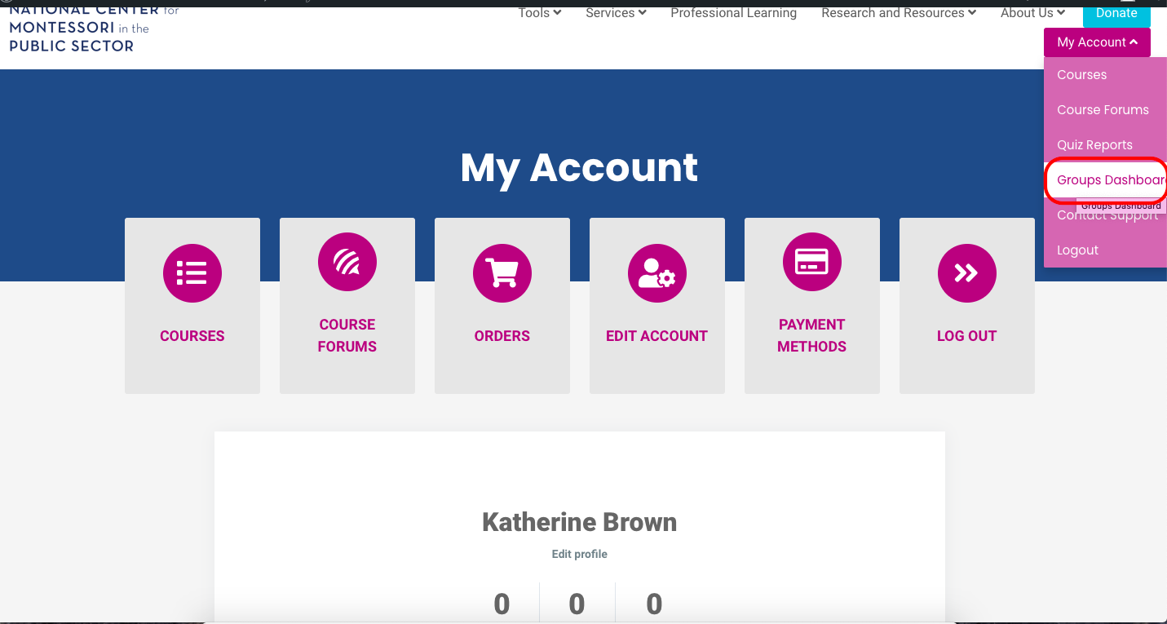

Once in the dashboard, select your group and scroll down to find the enroll new user button.
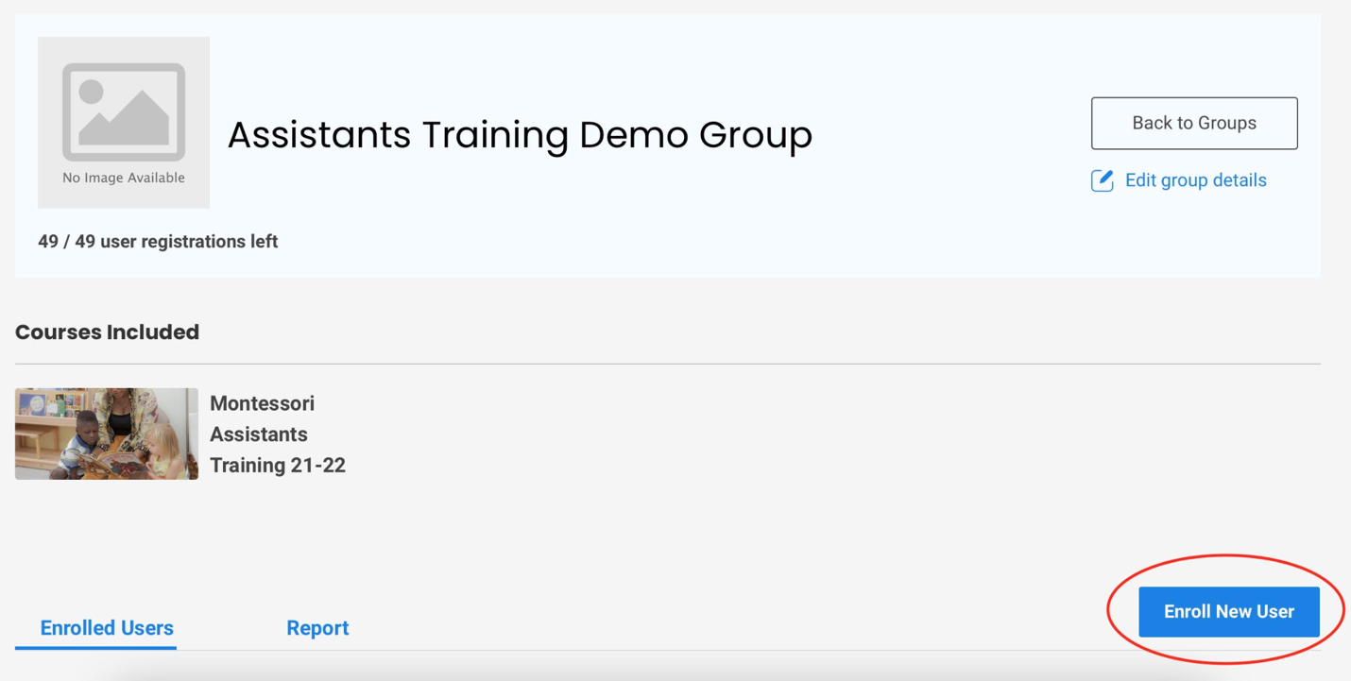

Guiding Participants to the Course

To access the Montessori Assistants Training, go to https://www.public-montessori.org/ and click “Login” in the upper right hand corner. Log in to your account, then click “My Account” and select “Courses.”

Select your course from the course dashboard, then scroll all the way to the bottom and click on the course name.
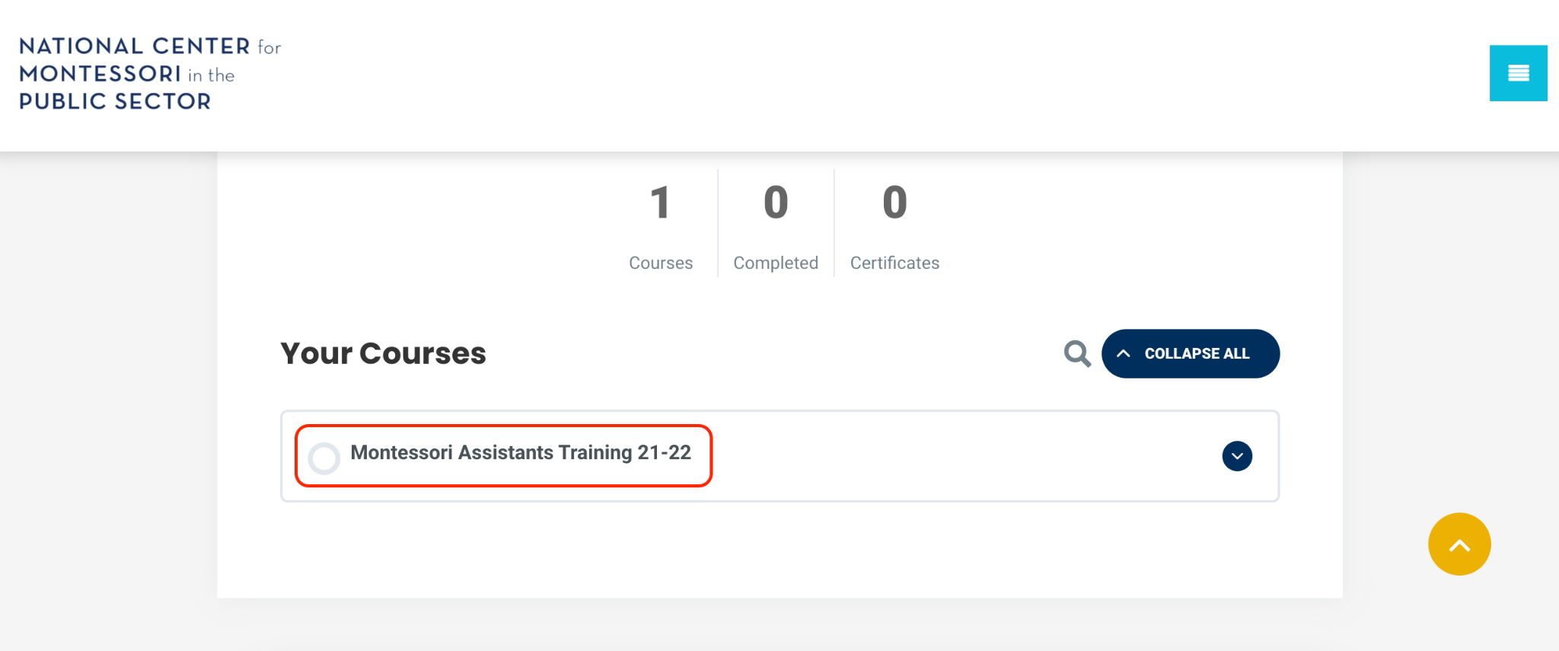

Scroll to the bottom again and you can access the course content by clicking on the module you would like to begin with.
